**Collaborate by using a shared repo**

Pulling directly from someone else's repository works, provided you're both on the same network. But, it's a clumsy process, and most collaborators aren't on the same network. It's better to set up a central repository that all collaborators can push to and pull from.

When you tell your developer friend Bob about your project and Bob asks to participate, that's exactly what you decide to do—set up a central repository, which is also called a *bare repository*.

**Create a bare repository**

What you need is a repository that doesn't have a working tree. A bare repository has several advantages over a working tree:

* Without a working tree, everybody can push changes without worrying about which branch is checked out.
* It's easy for Git to detect when another user has pushed changes that might conflict with yours.
* A shared repo scales to any number of developers. With a bare repo, you have to know only about the shared repo, and not about all the other collaborators from whom you might need to pull.
* By putting the shared repo on a server that you all can access, you don't have to worry about firewalls and permissions.
* You don't need separate accounts on the server because Git keeps track of who made each commit. (GitHub has millions of users who all share the git account. Everyone uses the Secure Shell (SSH) cryptographic network protocol, and users are distinguished by their public keys.)

Creating a bare repo for sharing is easy:

1. Create a new directory named *Shared.git* at the same level as the *Alice* and *Cats* directories to hold the bare repo:

Bash

cd ..

mkdir Shared.git

cd Shared.git

The directory name isn't important, but we'll refer to it as the *Shared.git* directory, or just the *shared* directory, in these exercises.

Naming the directory *Shared.git* follows the longstanding tradition of assigning bare repositories a name that ends in .git to distinguish them from working trees. It is a convention, but not a requirement.

1. Now, use the following command to create a bare repo in the shared directory:

Bash

git init --bare

1. When a repo is still bare, the git checkout command can't be used to set the name of the default branch. To accomplish this task, you can change the HEAD branch to point at a different branch; in this case, it's the main branch:

Bash

git symbolic-ref HEAD refs/heads/main

1. The next step is to get the contents of *your* repo into the shared repo. Use these commands to return to the project directory where your repo is stored, set up an origin remote, and perform an initial push:

Bash

cd ../Cats

git remote add origin ../Shared.git

git push origin main

1. Check the output. The output should indicate success:

Output

Counting objects: 12, done.

Delta compression using up to 2 threads.

Compressing objects: 100% (8/8), done.

Writing objects: 100% (12/12), 1.07 KiB | 0 bytes/s, done.

Total 12 (delta 1), reused 0 (delta 0)

To ../Shared.git

* [new branch] main -> main

1. You want push and pull to use the main branch of origin by default, as if you had made your repo by cloning it in the first place. But first, you need to tell Git which branch to track.

Bash

git branch --set-upstream-to origin/main

1. Check for this output:

Output

Branch main set up to track remote branch main from origin.

Git would complain if you try to run this command before the initial push, because the new repository had no branches. Git can't track a branch that doesn't exist. All Git is doing under the hood is looking in .git/refs/remotes/origin for a file named *trunk*.

**Set up for collaborators**

The next step is for Bob to clone the bare repository, and then for Alice to set the origin in their repo to target the shared repo for pushes and pulls.

1. Create a directory named *Bob* that's a sibling of the project directory, and then change to the *Bob* directory:

Bash

cd ..

mkdir Bob

cd Bob

1. Now, clone the shared repo (be sure to include the period at the end of the command):

Bash

git clone ../Shared.git .

1. Currently, Alice's repo is configured to push to and pull from their own repo. Use the following commands to change to the *Alice* directory and change origin to point to the shared repo:

Bash

cd ../Alice

git remote set-url origin ../Shared.git

**Begin collaborating**

Now that Bob is set up to work on the website, Bob decides to add a footer to the bottom of the page. Let's take on Bob and Alice's persona for a few moments and learn the basics of collaboration.

1. Begin by going to the *Bob* directory and working as Bob:

Bash

cd ../Bob

git config user.name Bob

git config user.email bob@contoso.com

1. Open *index.html* and replace the <hr> element with this line (found at the end of the <body> element):

HTML

<footer><hr>Copyright (c) 2021 Contoso Cats</footer>

Then, save the file and close the editor.

1. Commit the changes and push to the remote origin:

Bash

git commit -a -m "Put a footer at the bottom of the page"

git push

1. Check the output. If you see a warning like the following example, don't worry. This warning just lets users know about a change to Git's default behaviors. If you'd like to make sure that you don't see this warning again, you can run git config --global push.default simple.

Output

warning: push.default is unset; its implicit value has changed in

Git 2.0 from 'matching' to 'simple'. To squelch this message

and maintain the traditional behavior, use:

git config --global push.default matching

To squelch this message and adopt the new behavior now, use:

git config --global push.default simple

When push.default is set to 'matching', git will push local branches

to the remote branches that already exist with the same name.

Since Git 2.0, Git defaults to the more conservative 'simple'

behavior, which only pushes the current branch to the corresponding

remote branch that 'git pull' uses to update the current branch.

See 'git help config' and search for 'push.default' for further information.

(the 'simple' mode was introduced in Git 1.7.11. Use the similar mode

'current' instead of 'simple' if you sometimes use older versions of Git)

1. While Bob is editing the site, Alice is, too. Alice decides to add a nav bar to the page. This addition requires Alice to modify two files: *index.html* and *site.css*. Begin by returning to the *Alice* directory:

Bash

cd ../Alice

1. Now, open *index.html* and insert the following line right after the <body> tag on line 8:

HTML

<nav><a href="./index.html">home</a></nav>

Then, save the file and close the editor.

1. Then, open *site.css* in the *CSS* folder and add the following line at the bottom:

css

nav { background-color: #C0D8DF; }

Save the file and close the editor.

1. Now, let's assume that Alice receives an e-mail from Bob saying that Bob made changes to the site. Alice decides to pull Bob's changes before committing their own. (If Alice had already committed their changes, they would have a different problem, which is discussed in another module.) Alice runs this command:

Bash

git pull

1. Check the output. From the output, it looks as if Git has prevented a problem:

Output

remote: Counting objects: 3, done.

remote: Compressing objects: 100% (3/3), done.

remote: Total 3 (delta 2), reused 0 (delta 0)

Unpacking objects: 100% (3/3), done.

From ../Shared

843d142..2cf6cbf main -> origin/main

Updating 843d142..2cf6cbf

error: Your local changes to the following files would be overwritten by merge:

index.html

Please commit your changes or stash them before you can merge.

Aborting

Git warns that the pull would overwrite Alice's version of *index.html* and lose their changes. That's because Bob modified *index.html*, too. If Alice hadn't changed *index.html*, Git would have committed the merge.

1. Use a git diff command to see what changes Bob made to *index.html*:

Bash

git diff origin -- index.html

1. Check the output. From the output, it's evident that Alice's changes and Bob's changes don't overlap. Now, Alice can *stash* their changes.

git stash saves the state of the working tree and index by making a couple temporary commits. Think of the stash as a way to save your current work while you do something else, without making a "real" commit or affecting your repository history.

In reality, Alice should have stashed or committed their changes before they tried to pull. Pulling to a "dirty" working tree is risky, because it can do things from which you can't easily recover.

Use the following command to stash Alice's changes:

Bash

git stash

1. Check the output. It should look like this example:

Output

Saved working directory and index state WIP on main: 95bbc3b Change background color to light blue

HEAD is now at 95bbc3b Change background color to light blue

1. Now, it's safe for Alice to pull, after which they can "pop" the stash, which is organized as a stack. (In fact, git stash is shorthand for git stash push. It's a lot like the stack where you put bills that you haven't gotten around to paying yet.) Run these commands:

Bash

git pull

git stash pop

Popping the stash merges the changes. If changes overlap, there might be a conflict. You can learn how to resolve those situations in a more advanced Git module from Microsoft Learn.

1. Check the output. Alice should see this output, which lets them know that the merge was successful and that their changes are back, but not yet staged for commit:

Output

Auto-merging index.html

On branch main

Your branch is up-to-date with 'origin/main'.

Changes not staged for commit:

(use "git add <file>..." to update what will be committed)

(use "git checkout -- <file>..." to discard changes in working directory)

modified: CSS/site.css

modified: index.html

no changes added to commit (use "git add" and/or "git commit -a")

Dropped refs/stash@{0} (0cfb7b75d56611d9fc6a6ab660a51f5582b8d9c5)

At this point, Alice can continue working or just commit and push their changes. Let's make another change as Alice by assigning footers the same style as nav bars.

1. Open *site.css* in the *CSS* folder and replace the third line—the one that styles <nav> elements—with this shared CSS rule. Then, as usual, save your changes and close the editor.

HTML

nav, footer { background-color: #C0D8DF; }

1. Now, commit the changes and push them to the shared repo:

Bash

git commit -a -m "Stylize the nav bar"

git push

The updated site is now in the shared repo.

1. Finish up returning to the project directory and doing a pull:

Bash

cd ../Cats

git pull

1. Open *index.html* (the one in the project directory) to confirm that the changes made by both Bob and Alice are present in your local repo by. Verify that *index.html* has the most up-to-date code:

HTML

<!DOCTYPE html>

<html>

<head>

<meta charset='UTF-8'>

<title>Our Feline Friends</title>

<link rel="stylesheet" href="CSS/site.css">

</head>

<body>

<nav><a href="./index.html">home</a></nav>

<h1>Our Feline Friends</h1>

<p>Eventually we will put cat pictures here.</p>

<footer><hr>Copyright (c) 2021 Contoso Cats</footer>

</body>

</html>

1. At the moment, your repo and Alice's repo are synced, but Bob's repo is not. Finish up by getting Bob up to date, too:

Bash

cd ../Bob

git pull

All three repos are now in alignment. The shared repo is the single source of truth for all users, and all pushes and pulls are directed to the shared repo.

If you're curious what the website looks like, here's a preview:

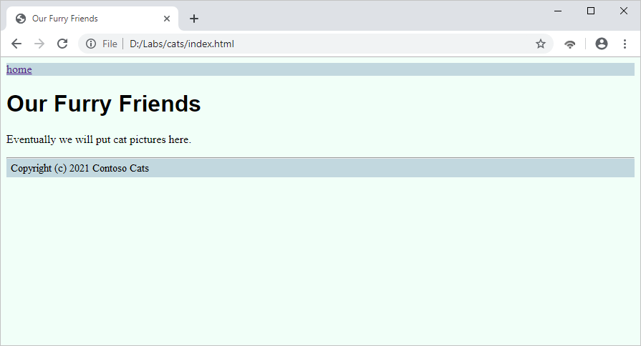

If you'd like, you can download your files to preview them locally:

1. Zip the *Cats* folder:

Bash

cd ..

zip -r Cats.zip Cats

1. Download the zipped file:

Bash

download Cats.zip

1. Now, unzip the file on your local computer and open *index.hml* to see for yourself!